Group #: 3

**SQL-Mongo Project – Spatial Data of US Wildfires**

BUAN 6320

Group Members

**Siddhartha Bingi**

**Alekhya Ravilla**

**Sparsh Sharma**

**Jerin Jose**

|  |  |  |  |  |
| --- | --- | --- | --- | --- |
| **Activity** | **Siddhartha Bingi** | **Alekhya Ravilla** | **Sparsh Sharma** | **Jerin Jose** |
| Prepared Data Model and Created Physical DB | X | X | X | X |
| Loaded Data into Database | X | X | X | X |
| Wrote SQL Queries |  |  |  |  |
| Prepared Mongo Database |  |  |  |  |
| Loaded data into Mongo DB |  |  |  |  |
| Wrote Mongo Queries |  |  |  |  |
| Prepared Report | X | X |  |  |
| Reviewed Report |  |  | X | X |

Contents

Data Model 5

Assumptions/Notes About Data Entities and Relationships 5

Entity-Relationship Diagram 5

Physical Database 6

Assumptions/Notes About Data Set 6

Screen shot of Physical Database objects 6

Data in the Database 6

SQL Queries 7

Query 1 7

Question 7

Notes/Comments About SQL Query and Results (Include # of Rows in Result) 7

Translation 7

Screen Shot of SQL Query and Results 7

Query 2 8

Question 8

Notes/Comments About SQL Query and Results (Include # of Rows in Result) 8

Translation 8

Screen Shot of SQL Query and Results 8

Query 3 9

Question 9

Notes/Comments About SQL Query and Results (Include # of Rows in Result) 9

Translation 9

Screen Shot of SQL Query and Results 9

Query 4 10

Question 10

Notes/Comments About SQL Query and Results (Include # of Rows in Result) 10

Translation 10

Screen Shot of SQL Query and Results 10

Query 5 11

Question 11

Notes/Comments About SQL Query and Results (Include # of Rows in Result) 11

Translation 11

Screen Shot of SQL Query and Results 11

Query 6 12

Question 12

Notes/Comments About SQL Query and Results (Include # of Rows in Result) 12

Translation 12

Screen Shot of SQL Query and Results 12

Data Review for MongoDB 13

Assumptions/Notes About Data Collections, Attributes and Relationships between Collections 13

Physical Mongo Database 14

Assumptions/Notes About Data Set 14

Screen shot of Physical Database objects (Database, Collections and Attributes) 14

Data in the Database 14

MongoDB Queries/Code 15

Query 1 15

Question 15

Notes/Comments About MongoDB Query/Code and Results (Include # of Documents in Result) 15

Translation 15

Screen Shot of MongoDB Query/Code and Results 15

Query 2 16

Question 16

Notes/Comments About MongoDB Query/Code and Results (Include # of Documents in Result) 16

Translation 16

Screen Shot of MongoDB Query/Code and Results 16

Query 3 17

Question 17

Notes/Comments About MongoDB Query/Code and Results (Include # of Documents in Result) 17

Translation 17

Screen Shot of MongoDB Query/Code and Results 17

Query 4 18

Question 18

Notes/Comments About MongoDB Query/Code and Results (Include # of Documents in Result) 18

Translation 18

Screen Shot of MongoDB Query/Code and Results 18

Query 5 19

Question 19

Notes/Comments About MongoDB Query/Code and Results (Include # of Documents in Result) 19

Translation 19

Screen Shot of MongoDB Query/Code and Results 19

Query 6 20

Question 20

Notes/Comments About MongoDB Query/Code and Results (Include # of Documents in Result) 20

Translation 20

Screen Shot of MongoDB Query/Code and Results 20

# Data Model

## Assumptions/Notes About Data Entities and Relationships

Include assumptions about data entities and their relationships with each other.

**Overview of Data Entities and their Relationships**

|  |  |  |  |
| --- | --- | --- | --- |
| **Fact Table (Child)** | **Dimension Table (Parent)** | **Relationship** | **Assumption** |
| fire_table  FOD_ID (PK) | - | - |  |
| FPA_ID (FK, NOT NULL) | source_system_table  FPA_ID (PK) | One to One | For each Fire record, there is only one FPA entry and for each FPA entry there is only one Fire record |
| UnitId (FK) | nwcg_agency_identifier_table  UnitId (PK) | Zero to Many | For each Fire record, there is zero or one NWCG UnitId and for each NWCG UnitId there is at least one Fire record |
| STAT_CAUSE_CODE (FK, NOT NULL) | Stat_cause_table  STAT_CAUSE_CODE(PK) | One to Many | For each Fire record, there is only one STAT_CAUSE entry and for each STAT_CAUSE entry there is at least one Fire record |
| LATITUDE (FK, NOT NULL)  LONGITUDE (FK, NOT NULL) | fire_location_table  LATITUDE, LONGITUDE (Composite PK) | One to Many | For each Fire record, there is only one LATITUDE/LONGITUDE (location) entry and for each LATITUDE/LONGITUDE entry there is at least one Fire record |
| MTBS_ID (FK) | mtbs_table  MTBS_ID (PK) | Zero to Many | For each Fire record, there is zero or one MTBS entry and for each MTBS entry there is at least one Fire record |
| SOURCE_REPORTING_UNIT (FK, NOT NULL ) | source_reporting_table  SOURCE_REPORTING_UNIT (PK) | One to Many | For each Fire record, there is only one SOURCE_REPORTING_UNIT entry and for each FPA entry there is at least one Fire record |
| OWNER_CODE (FK, NOT NULL) | owner_table  OWNER_CODE (PK) | One to Many | For each Fire record, there is only one OWNER entry and for each OWNER entry there is at least one Fire record |
| ICS_209_INCIDENT_NUMBER (FK) | incident_identifier_table  ICS_209_INCIDENT_NUMBER (PK) | Zero to Many | For each Fire record, there is zero or one ICS entry and for each ICS entry there is at least one Fire record |

|  |  |  |  |
| --- | --- | --- | --- |
| **Child Table** | **Parent Table** | **Relationship** | **Assumptions** |
| nwcg_agency_identifier_table  UnitId (PK)  State (FK, NOT NULL)  Gacc (FK, NOT NULL) | nwcg_location_table  State (PK)  Gacc (PK) | One to Many | For each NWCG unit record, there is only one location entry and for each location there is at least one NWCG unit |
| fire_location_table  LATITUDE (PK)  LONGITUDE (PK)  FIPS_CODE (FK)  FIPS_NAME (FK) | fips_table  FIPS_CODE (PK)  FIPS_NAME (PK) | Zero to Many | For each Location, there is zero or one FIPS record and for each FIPS record, there is at least one Location |

**How the Data Model has been built**

The given data has been split and grouped into logical entities such that each entity unambiguously describes its own atomic properties and any complex properties have been further split and grouped into separate child entities such that only the primary key columns are included as Foreign keys in parent entity.

1. The database has been designed using snowflake schema such that fire_table is the fact table and other tables are the dimension tables.
2. Each entry in fire_table can be uniquely identified by FOD-ID and all the other references to dimension tables are represented using Foreign Keys.
3. All the individual measurements of fire_table are defined as attributes and complex units are separated into dimension tables.
4. List of dimension tables: source_system_table, source_reporting_table, nwcg_agency_identifier_table, nwcg_location_table, incident_identifier_table, owner_table, mtbs_table, fire_location_table, fips_table, stat_cause_table

**1st Normal Form:**

Rule 1: Each table cell should contain a single value

Rule 2: Each record needs to be unique

* fire_table has been checked for multi-values and found none. Hence rule 1 is satisfied.
* FOD_ID is uniquely identifies each row - hence made Primary key

**2nd Normal Form:**

Rule 1: Must be in 1st Normal Form

Rule 2: No Partial dependencies

* Model is already in 1ST Normal Form hence Rule 1 satisfied
* Columns SOURCE_SYSTEM_TYPE, SOURCE_SYSTEM partially depend on FPA_ID. Hence separated into source_system_table with FPA_ID as PK and made FK in fire_table
* Columns Agency, Wildlandrole, Unittype, Department, Code, Name, Parent, State, Gacc, GeographicArea, Country partially depend on UnitId. Hence separated into nwcg_identifier_table with UnitId as PK. But columns GeographicArea, Country are partially dependent on State and Gacc columns, hence further broke down the entity to form a new entity – nwcg_location_table with columns Gacc, GeographicArea, State, Country – State and Gacc made Composite PK and made FK(s) in nwcg_identifier_table.
* Column STAT_CAUSE_DESCR partially depends on STAT_CAUSE_CODE hence separated into stat_cause_table with STAT_CAUSE_CODE as PK.
* Columns STATE, FIPS_CODE, FIPS_NAME, COUNTY partially depend on LATITUDE and LONGITUDE columns hence separating them into fire_location_table with LATITUDE and LONGITUDE as PK. Further COUNTY partially depends on FIPS_CODE and FIPS_NAME, hence separating them into fips_table with FIPS_CODE and FIPS_NAME as PK and FK in fire_location_table.
* Columns MTBS_FIRE_NAME partially depends on MTBS_ID hence separating them into mtbs_table with MTBS_ID as PK
* Columns OWNER_DESCR partially depends on OWNER_CODE hence separating them into owner_table with OWNER_ID as PK
* Columns SOURCE_REPORTING_UNIT_NAME partially depends on SOURCE_REPORTING_UNIT hence separating them into source_reporting table with SOURCE_REPORTING_UNIT as PK
* Columns ICS_209_NAME partially depends on ICS_209_INCIDENT_NUMBER hence separating them into incident_identifier_table with ICS_209_INCIDENT_NUMBER as PK
* After performing the above steps, the entire model is in 2nd Normal Form

**3rd Normal Form**

Rule 1: Must be in 2nd Normal Form

Rule 2: No Transitive Dependencies

* The model is already in 2nd Normal Form satisfying Rule 1
* Columns NWCG_REPORTING_UNIT_ID, NWCG_REPORTING_AGENCY and NWCG_REPORTING_UNIT_NAME have transitive dependency on UnitId, Agency and Name. Hence removed these columns to satisfy Rule 2. With this, the model is in 3rd Normal Form

**Include reasons why the data model is in 3NF**

* Each table defines unambiguously specific functionality
* Every table has a primary key that uniquely identifies a row and each table contains only atomic values and refers to complex/group values through foreign keys. These complex/ group values are further divided into tables with appropriate Primary Keys
* Every column in each table is completely dependent on primary key after removing all the partial dependencies as explained in the earlier section
* All the transitive dependencies have been removed as explained in the earlier section

## Entity-Relationship Diagram

# Physical Database

## Assumptions/Notes About Data Set

Include any assumptions made about data such as empty fields, sparse data, bad data, etc.

Data Handling/ Cleanup

* The redundant columns in source data have been merged. UnitId and NWCG_REPORTING_UNIT_ID, Agency and NWCG_REPORTING_AGENCY, NWCG_REPORTING_UNIT_NAME and Name are such cases
* The source data has bad data in the form: lower/upper case letters interchangeably used. Such rows are grouped by code/id and merged into one record. One such case is “National Forests in Texas” and “National Forests IN Texas”
* Redundant data has been removed to retain the 3NF form of data model. Like in case of FIPS_TABLE, for unique FIPS_NAME, FIPS_CODE, there were multiple COUNTY values
* Missing Values and duplicate data have been removed

## Screen shot of Physical Database objects

FIRE_TABLE:

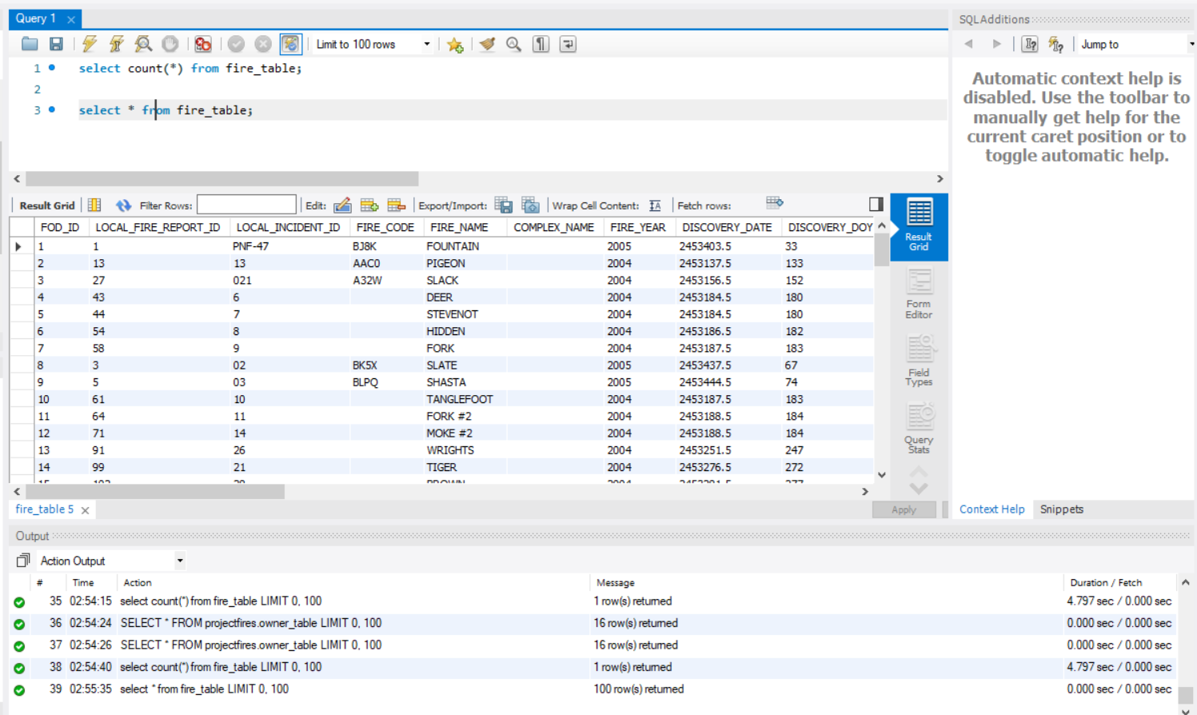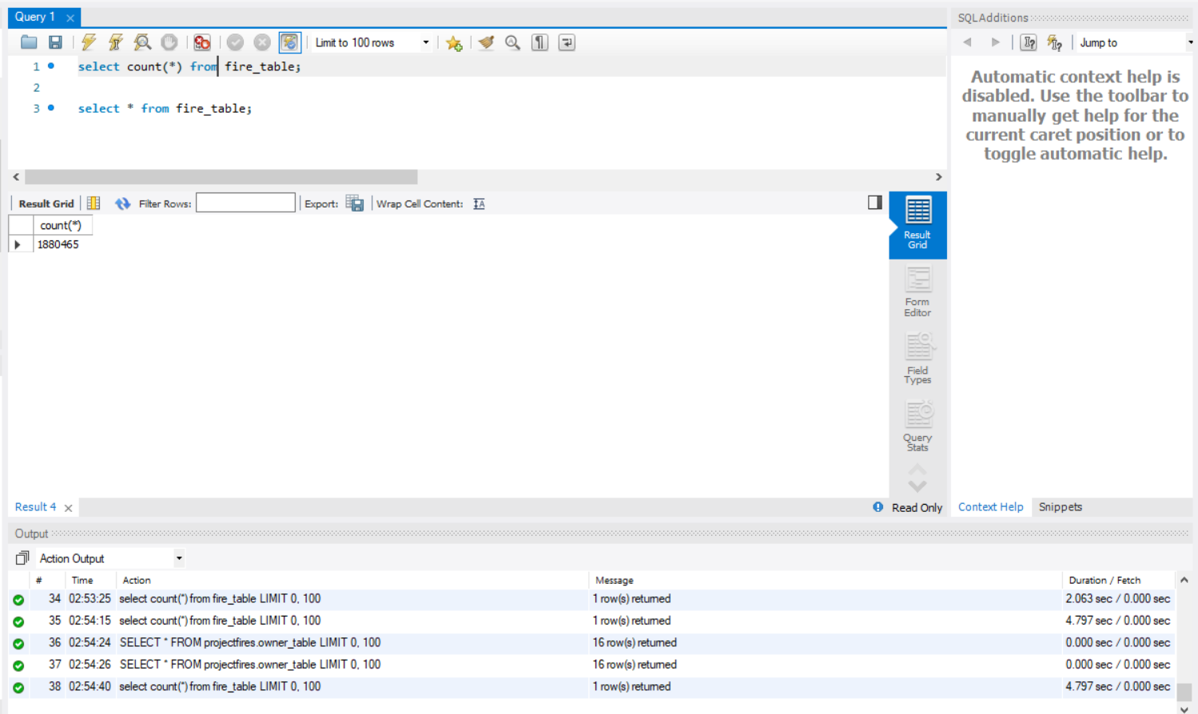

FIRE_LOCATION_TABLE:

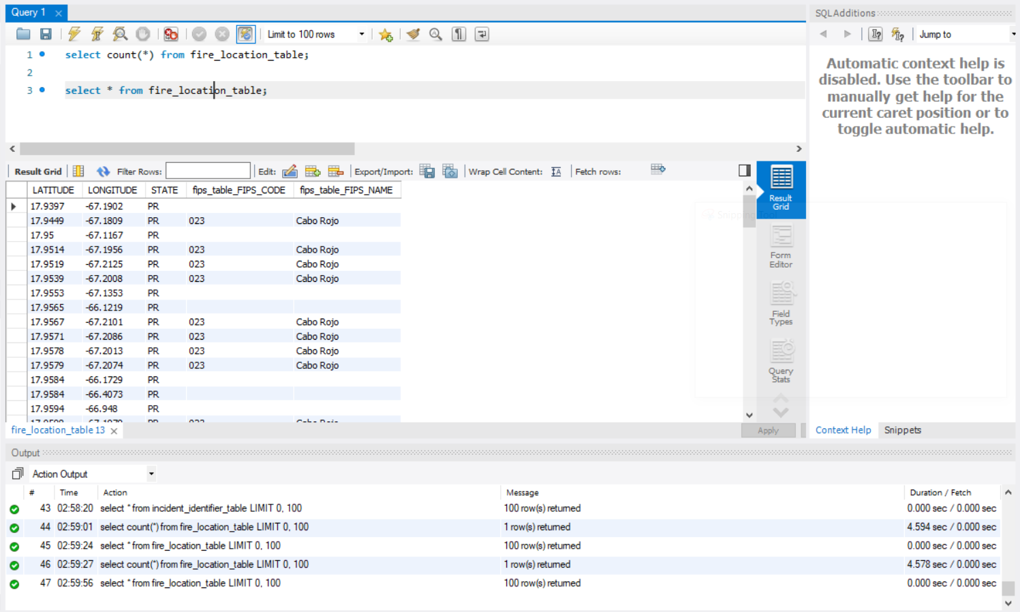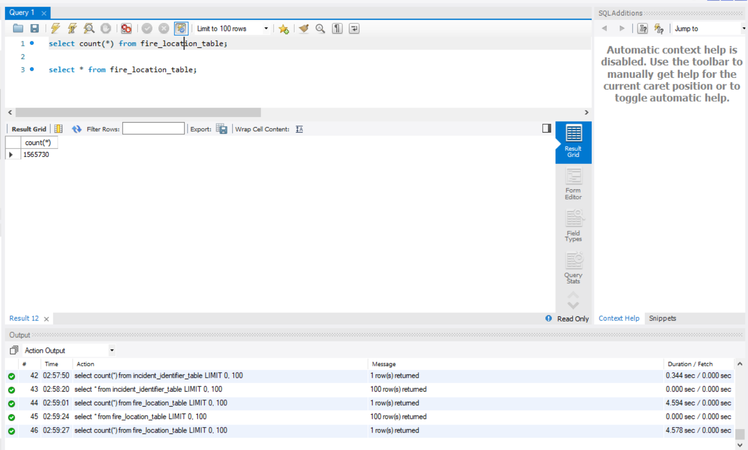

FIPS_TABLE:

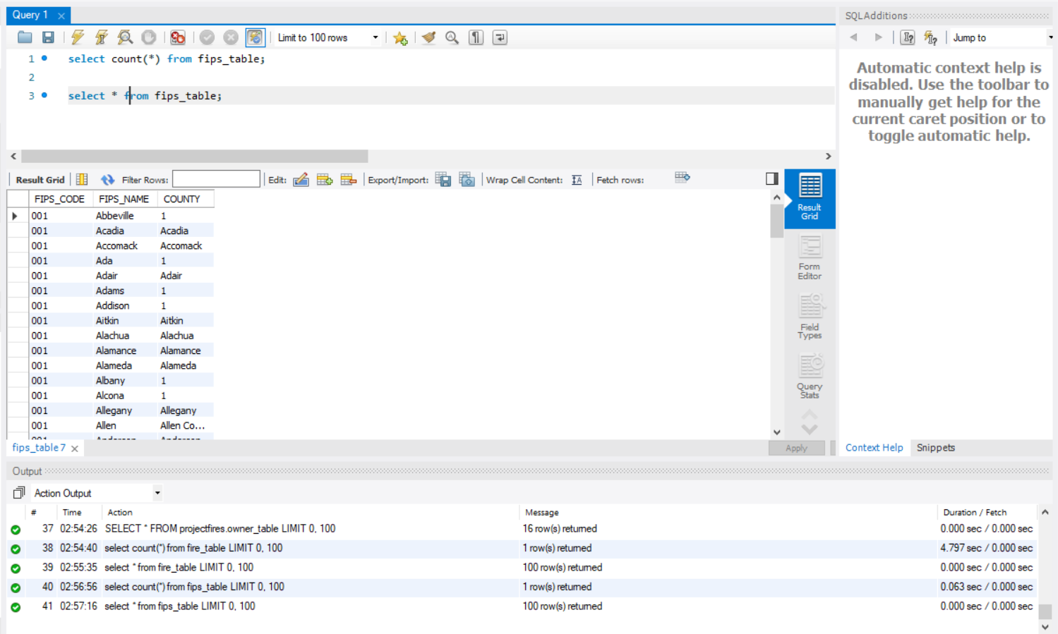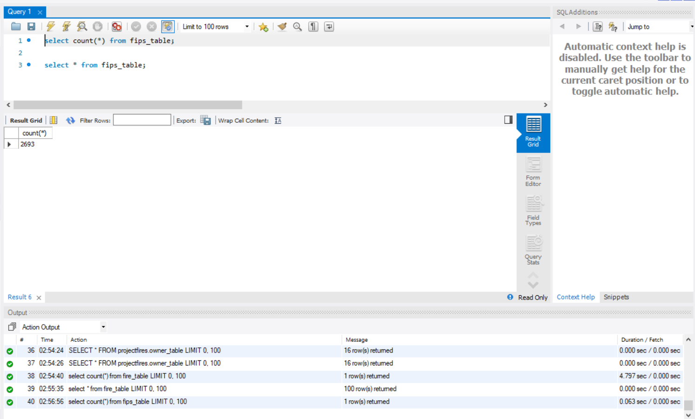

STAT_CAUSE_TABLE:

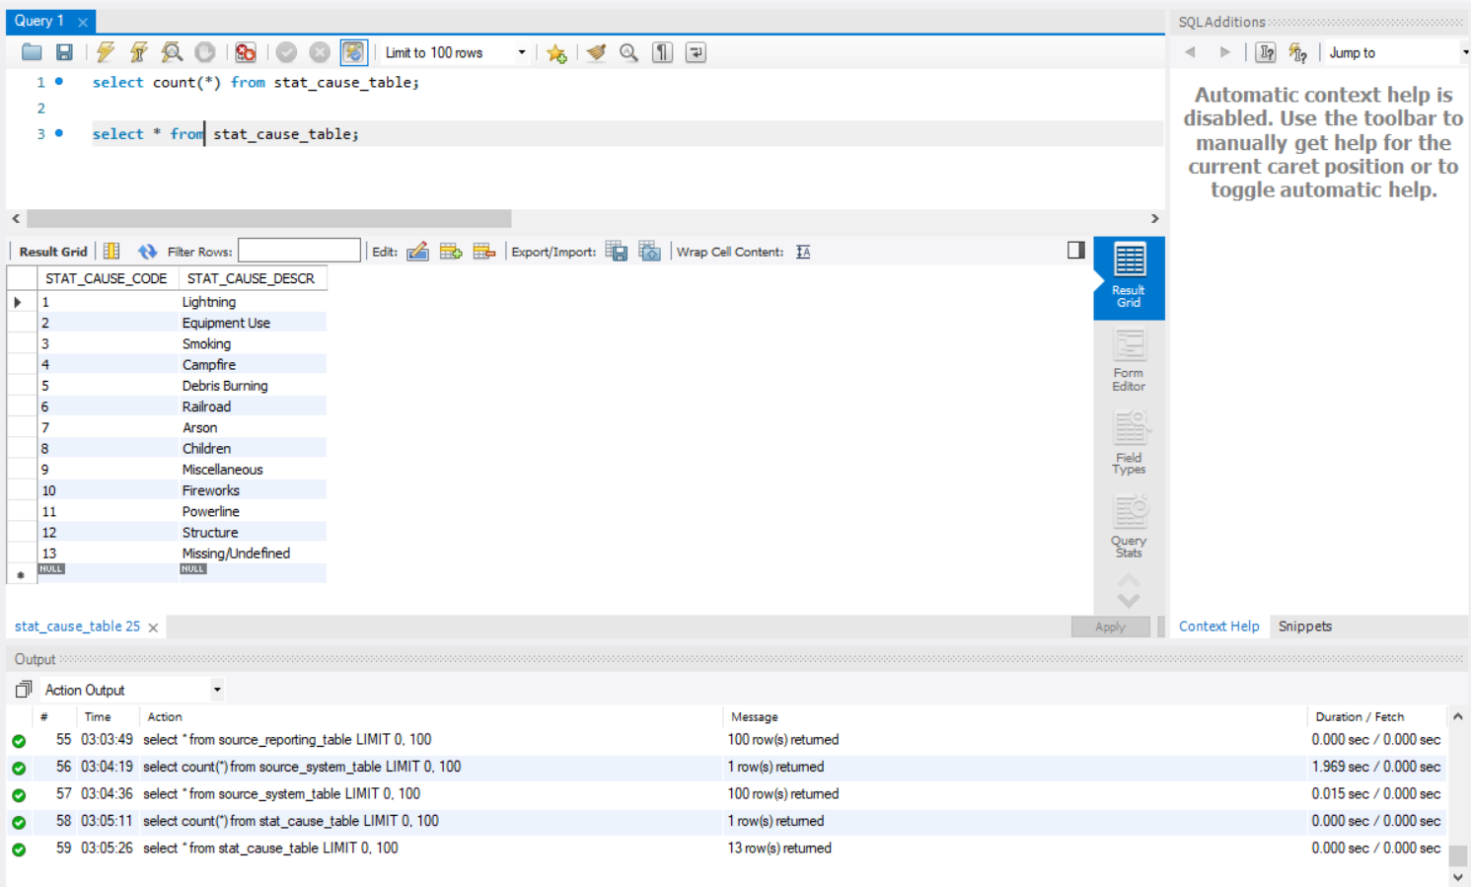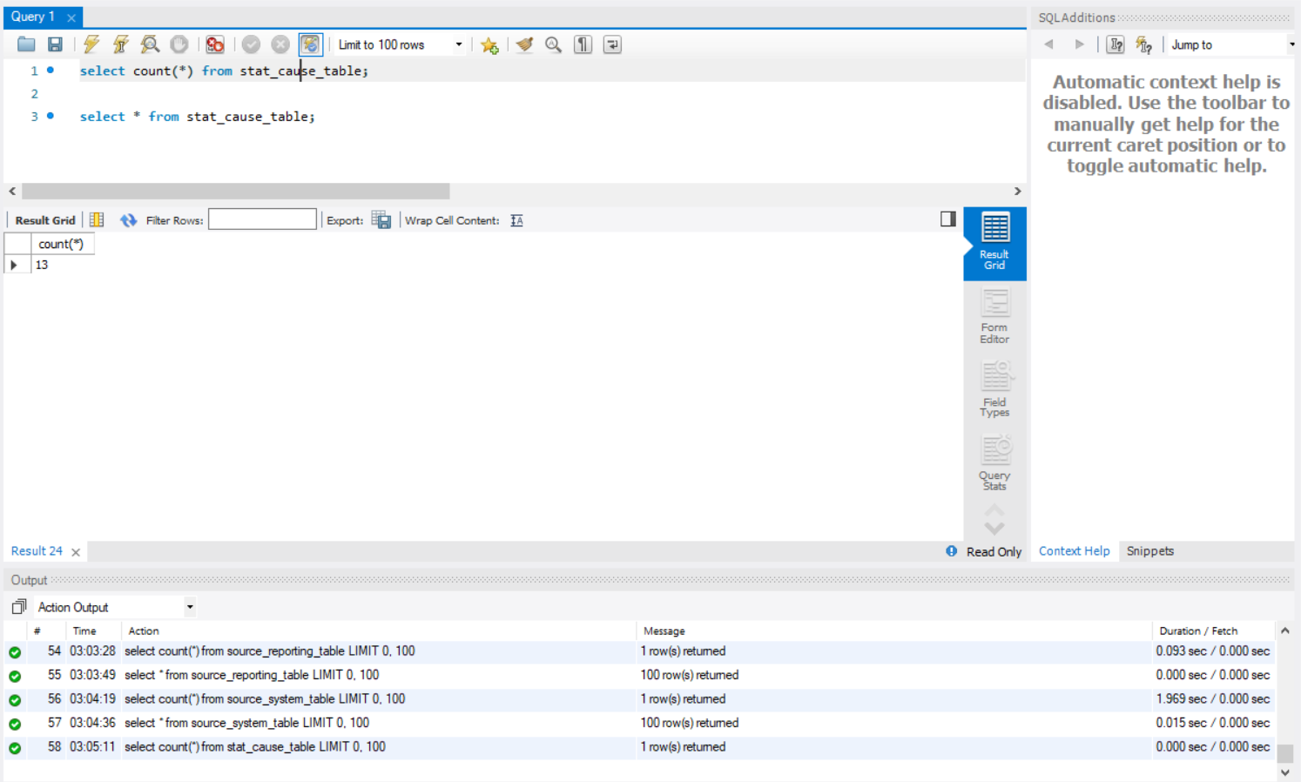

OWNER_TABLE:

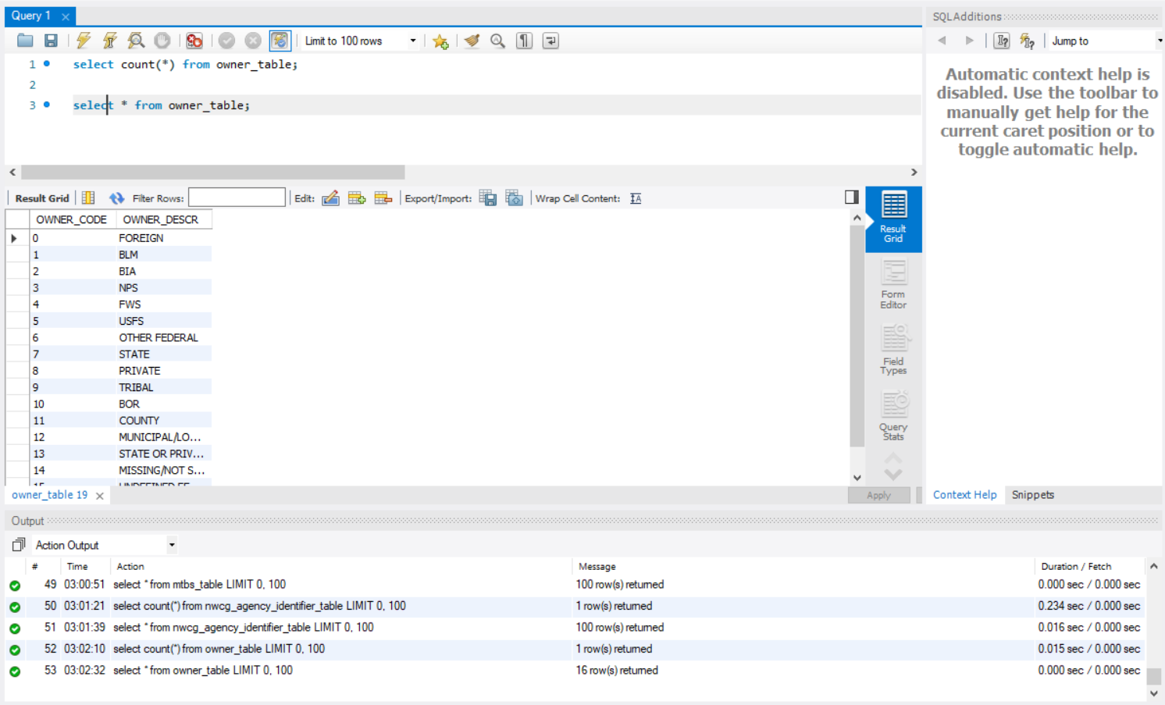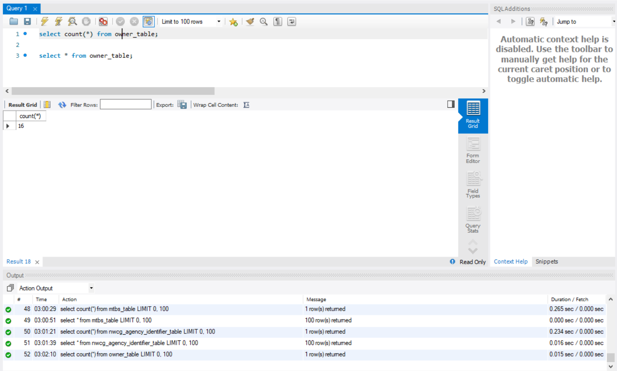

INCIDENT_IDENTIFIER_TABLE:

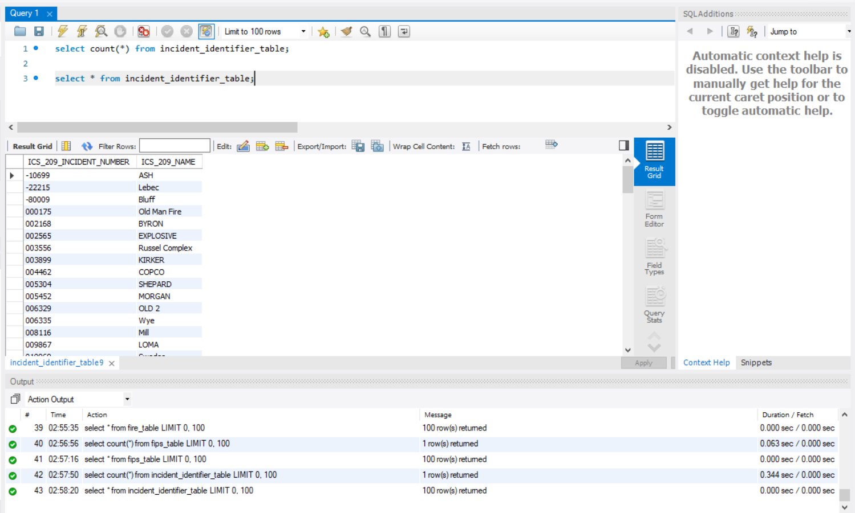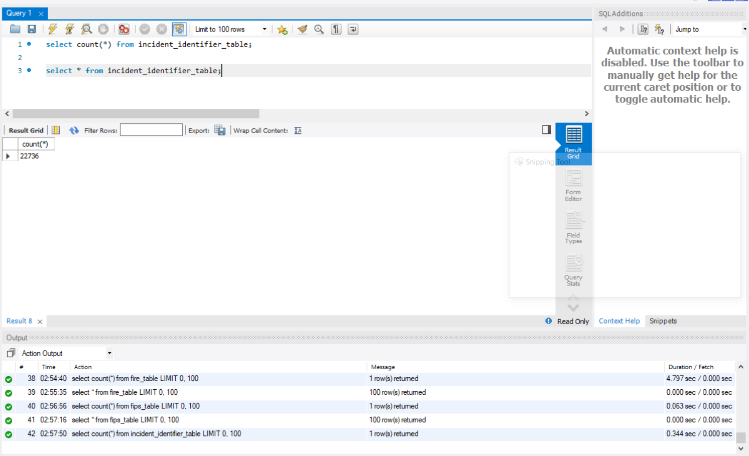

NWCG_AGENCY_IDENTIFIER_TABLE:

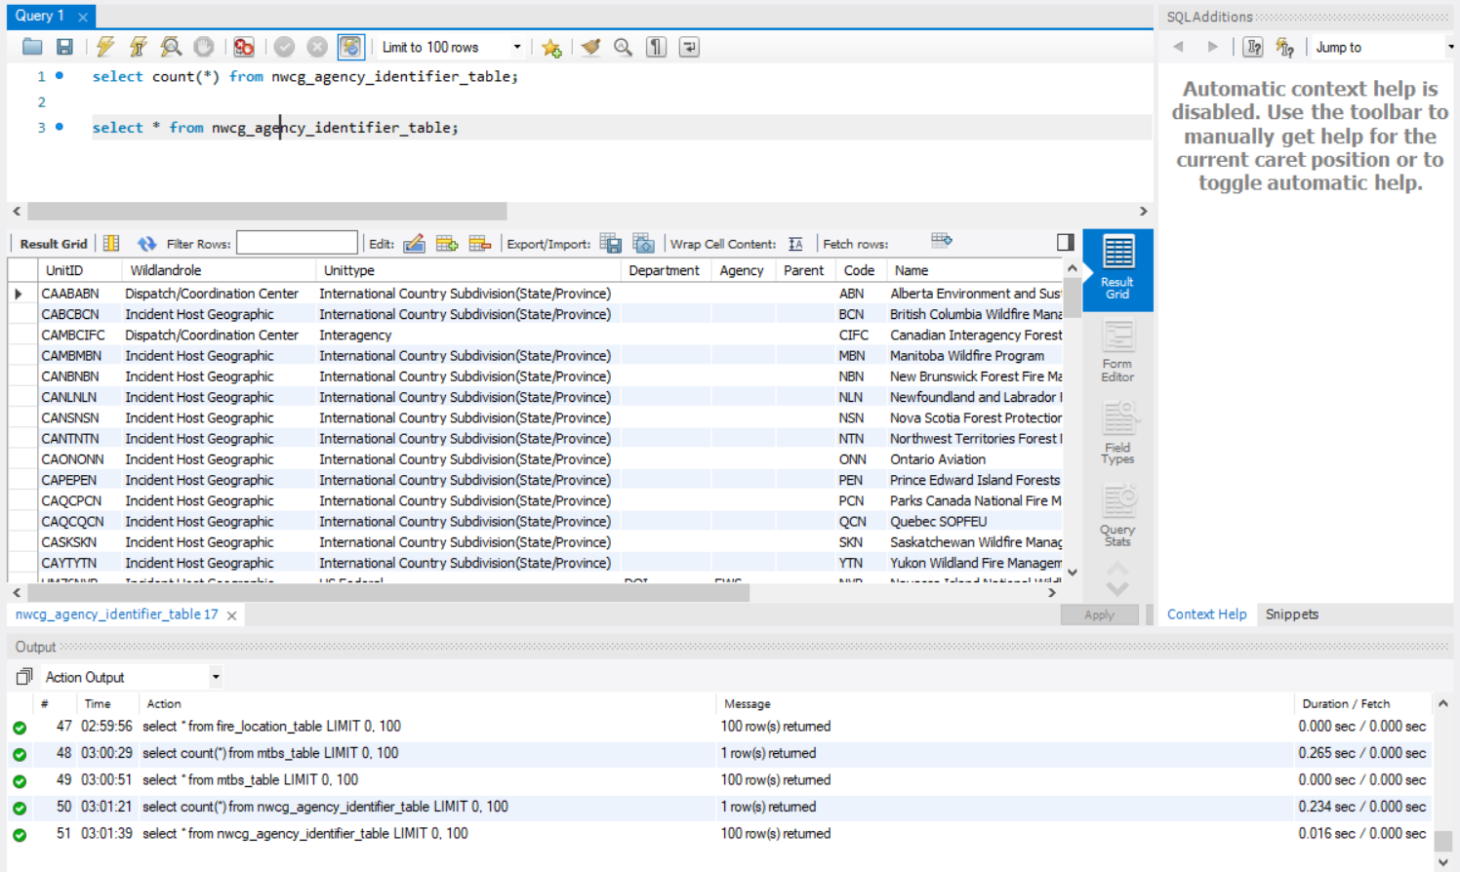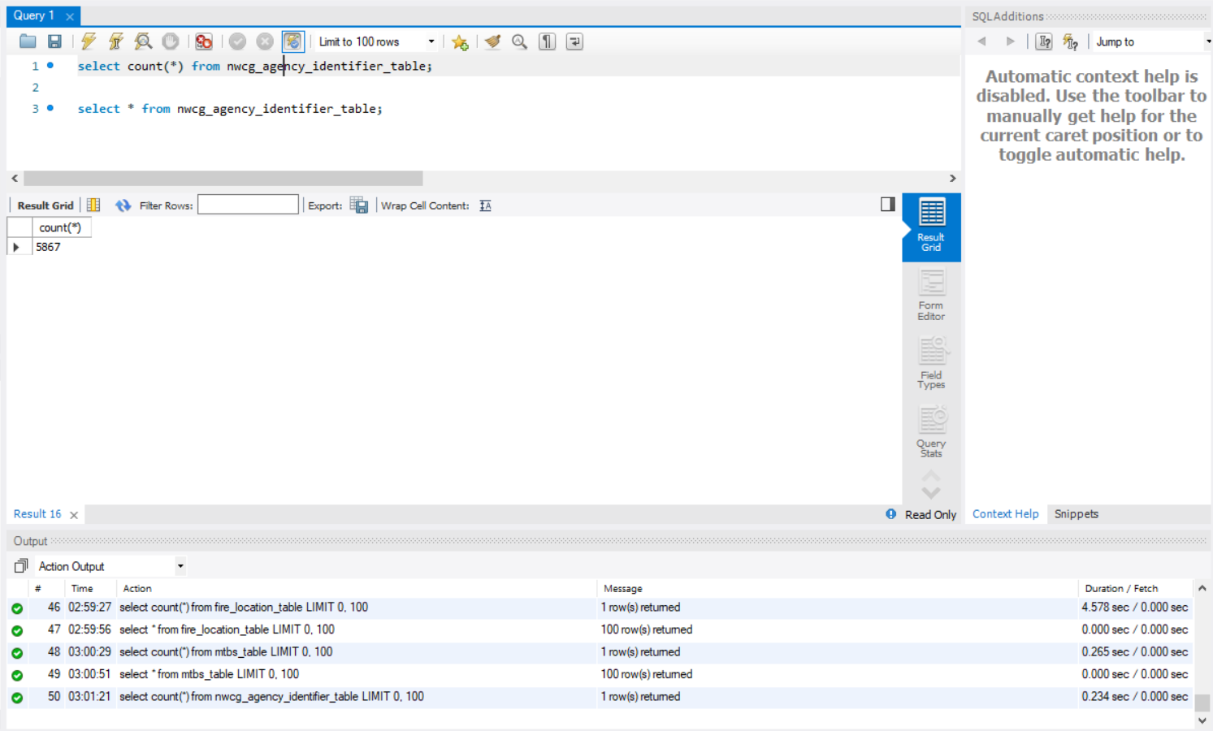

NWCG_LOCATION_TABLE:

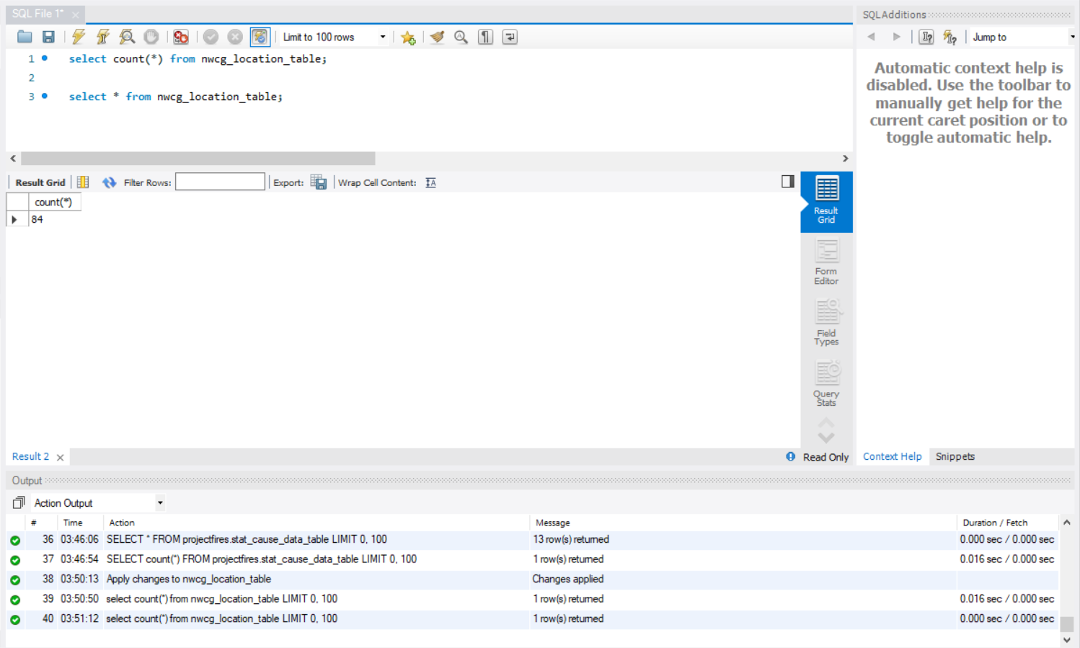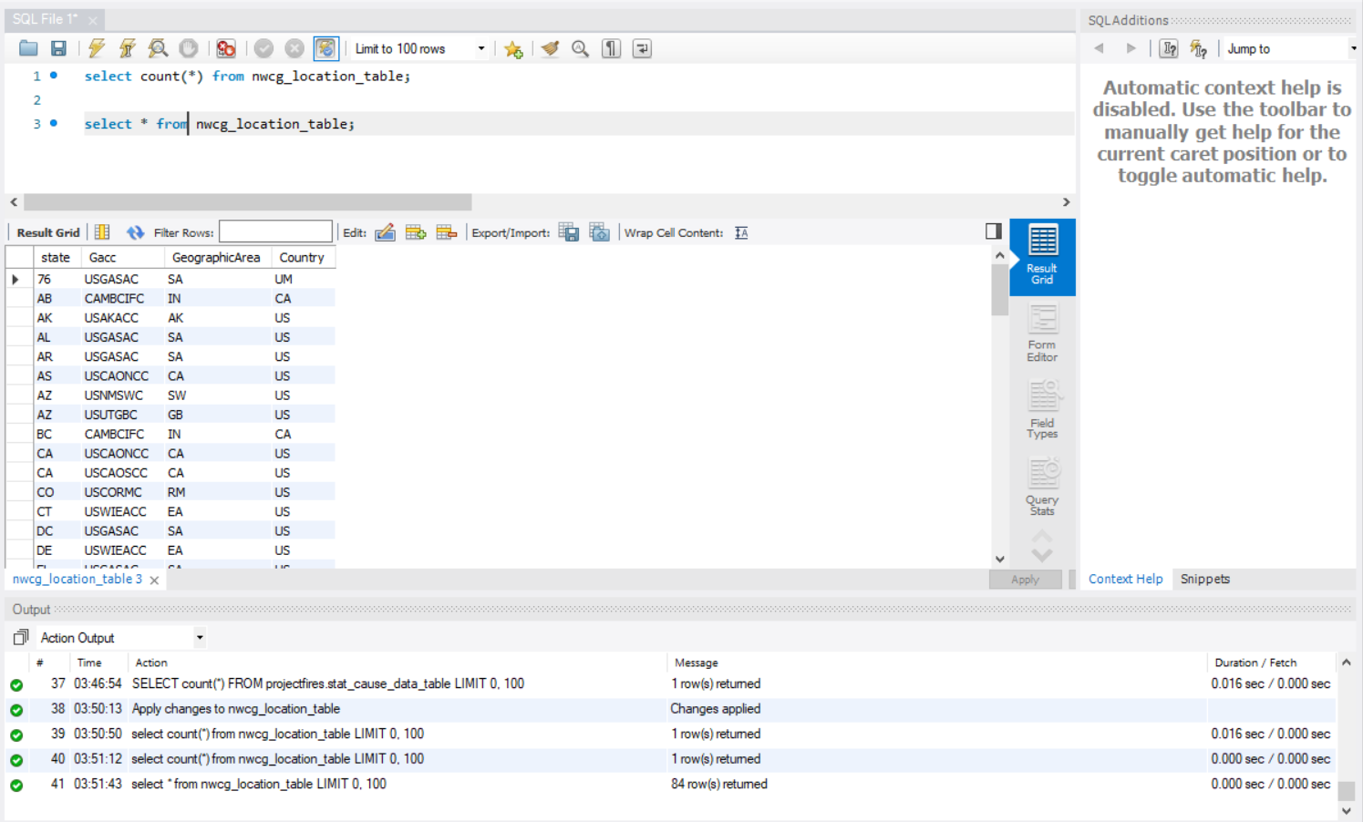

MTBS_TABLE:

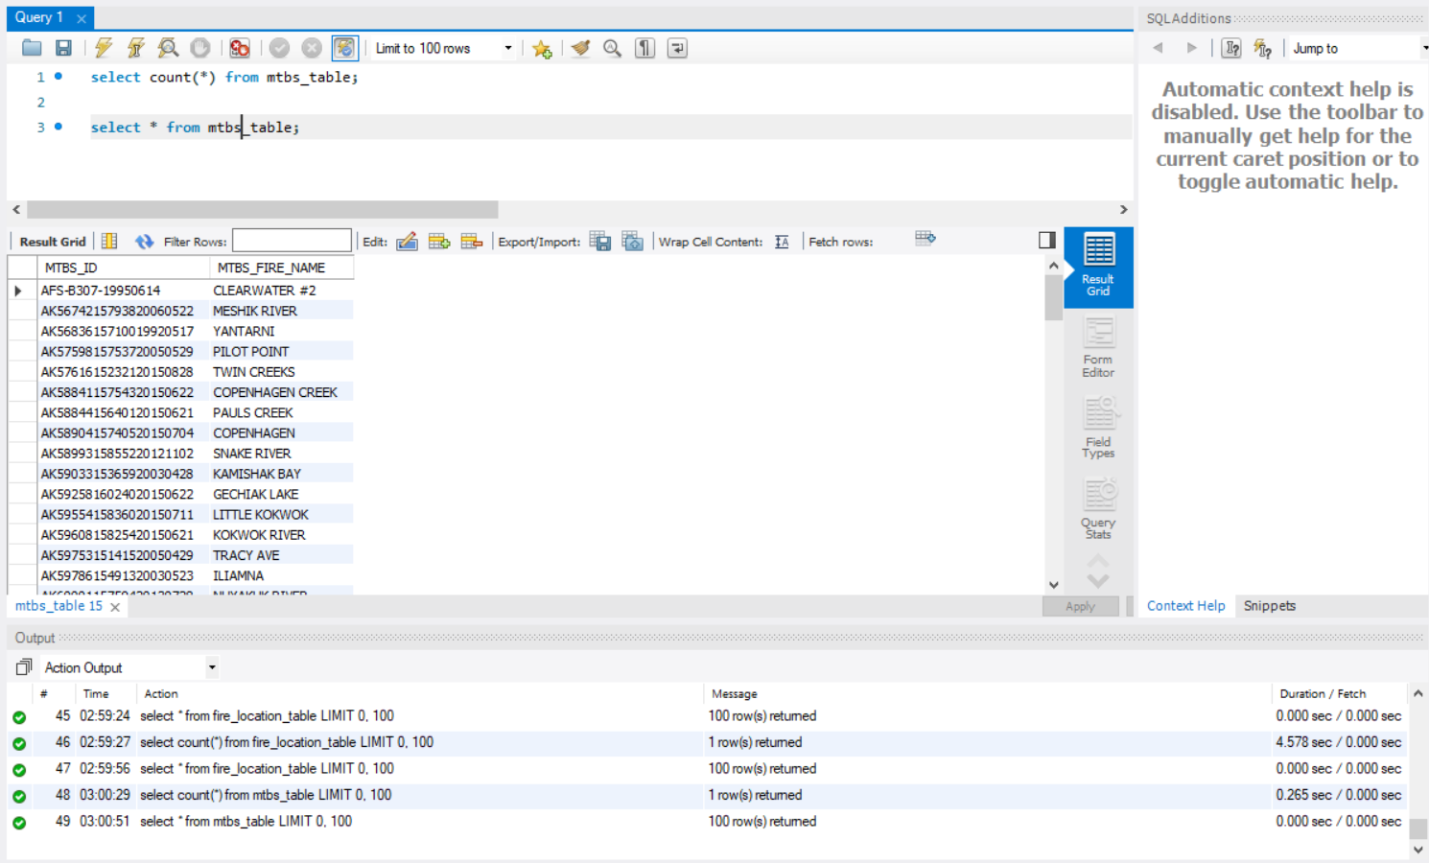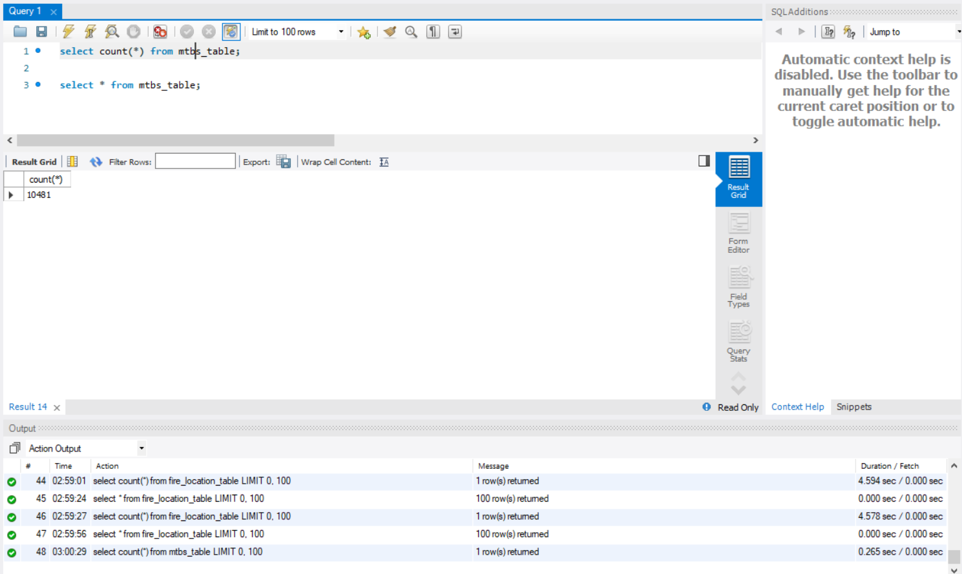

SOURCE_REPORTING_TABLE:

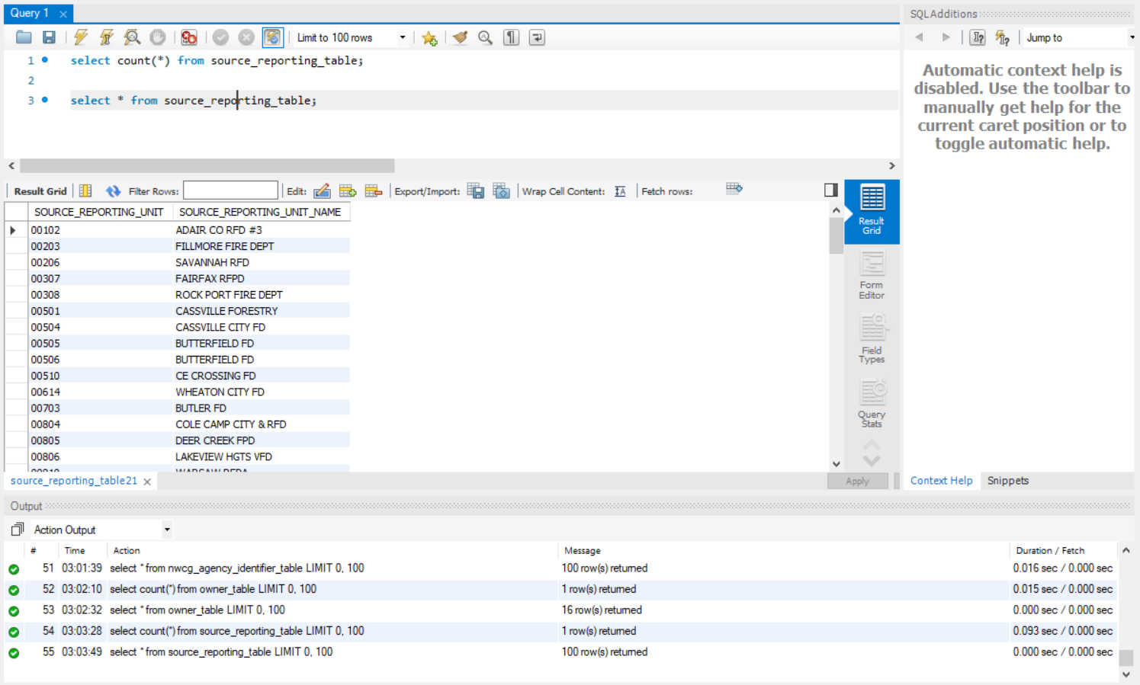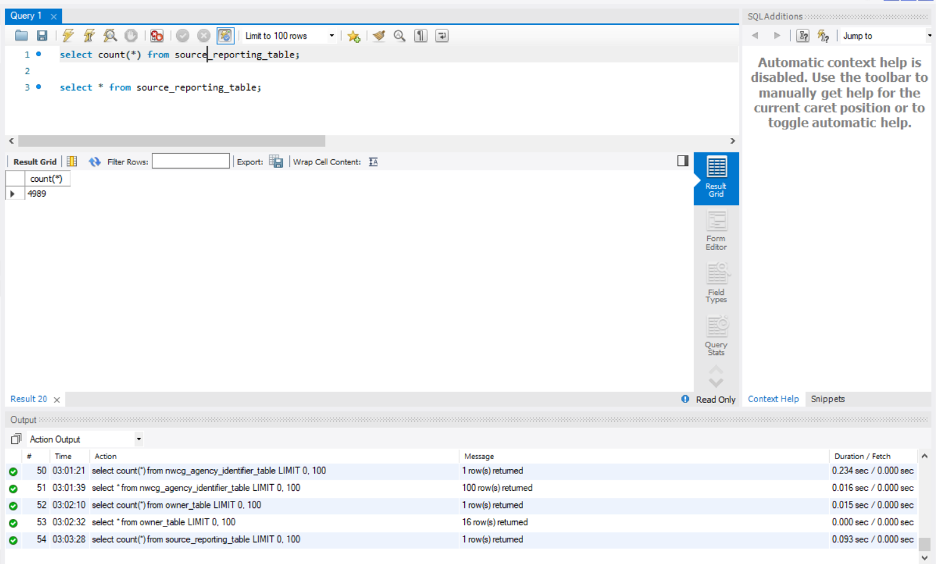

SOURCE_SYSTEM_TABLE:

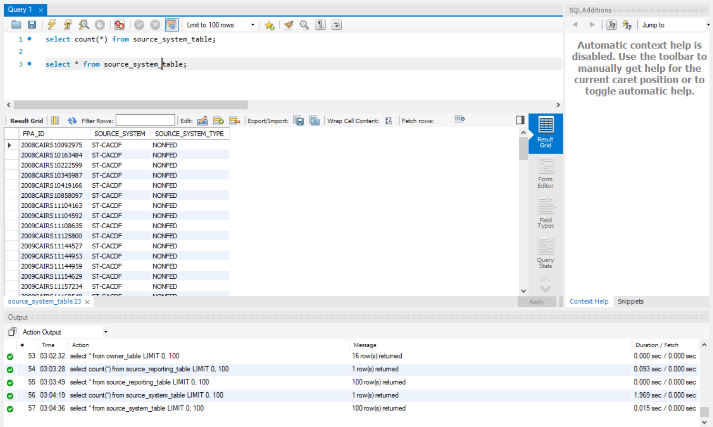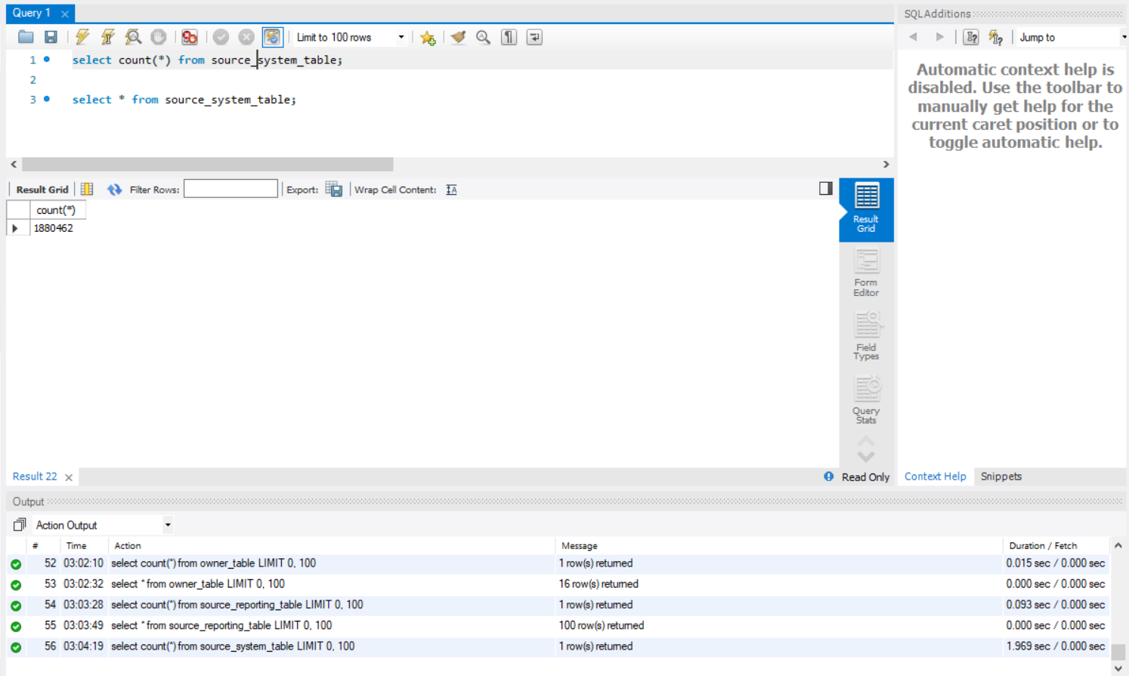

## Data in the Database

|  |  |  |  |
| --- | --- | --- | --- |
| **Table Name** | **Primary Key** | **Foreign Key** | **# of Rows in Table** |
| FIRE_TABLE | FOD_ID | FPA_ID  SOURCE_REPORTING_UNIT  MTBS_ID  NWCG_UnitID  (STATE,Gacc)  ICS_209_INCIDENT_NUMBER  OWNER_CODE,  STAT_CAUSE_CODE  (FIPS_CODE,FIPS_NAME)  (LATITUDE,LONGITUDE) | 1880465 |
| FIRE_LOCATION_TABLE | (Latitude, Longitude) | (FIPS_CODE, FIPS_NAME) | 1565730 |
| FIPS_TABLE | (FIPS_CODE, FIPS_NAME) |  | 2693 |
| STAT_CAUSE_TABLE | STAT_CAUSE_CODE |  | 13 |
| OWNER_TABLE | OWNER_CODE |  | 16 |
| INCIDENT_IDENTIFIER_TABLE | ICS_209_INCIDENT_NUMBER |  | 22736 |
| NWCG_AGENCY_IDENTIFIER_TABLE | UnitID |  | 5867 |
| NWCG_LOCATION_TABLE | (state,Gacc) |  | 84 |
| MTBS_TABLE | MTBS_ID |  | 10481 |
| SOURCE_REPORTING_TABLE | SOURCE_REPORTING_UNIT |  | 4989 |
| SOURCE_SYSTEM_TABLE | SOURCE_SYSTEM_TABLE |  | 1880462 |

# SQL Queries

## Query 1

### Question

A leading beverage company has announced a billion-dollar fund for removing debris from forests, rivers and mountains in the US. All states are interested. Which 2 states have the least chance to win a share of the fund?

### Notes/Comments About SQL Query and Results (Include # of Rows in Result)

# of rows in the result: 2

### Translation

TRANSLATION: select the states from fire_table joined with fire_location_table on LATITUDE and LONGITUDE joined with stat_cause_table on STAT_CAUSE_CODE where stat_cause_table STAT_CAUSE-DESCR equals Debris Burning, grouping the result by STATE, ordering it by count of STATE in ascending order and displaying the top 2 results.

CLEAN UP: SELECT STATE FROM fire_table AS ft JOIN fire_location_table AS flt

ON ft.location_LATITUDE =flt.LONGITUE AND ft.location_LONGITUDE=flt.LONGITUDE

JOIN stat_cause_table AS sct ON ft.stat_cause_table_STAT_CAUSE_CODE= sct.STAT_CAUSE_CODE

WHERE sct.STAT_CAUSE_CODE=’Debris Burning’

GROUP BY flt.STATE

ORDER BY COUNT (flt.STATE)

LIMIT 2;

### Screen Shot of SQL Query and Results

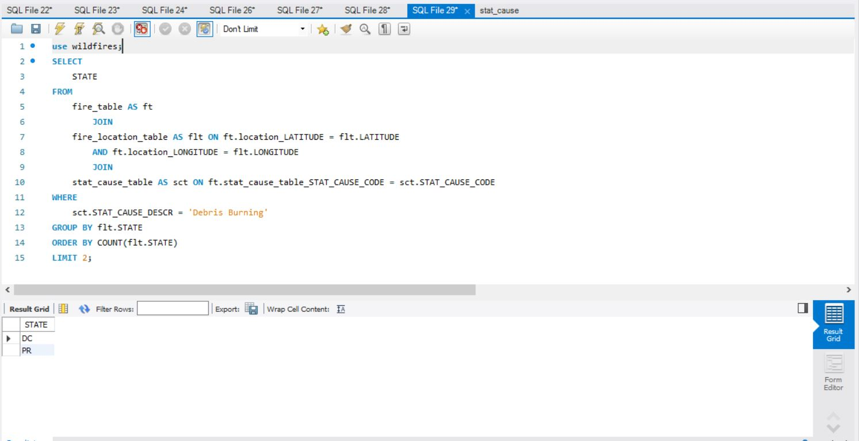

## Query 2

### Question

One of the reporting agencies has suggested that children be banned from its forests unless there is one adult for every 4 children in a group visiting a forest. Name top 5 forests where this would be the least appropriate.

### Notes/Comments About SQL Query and Results (Include # of Rows in Result)

# of rows in the result: 5

### Translation

TRANSLATION: select SOURCE_REPORTING_UNIT_NAME from fire_table joined with source_reporting_table on SOURCE_REPORTING_UNIT joined with stat_cause_table on STAT_CAUSE_CODE where stat_cause_STAT_CAUSE_CODE equals 8 and source_reporting_table_ SOURCE_REPORTING_UNIT_NAME ends with FOREST, group by SOURCE_REPORTING_UNIT_NAME, order it by COUNT(SOURCE_REPORTING_UNIT_NAME), SOURCE_REPORTING_UNIT_NAME in ascending order and display the top 5 results.

CLEANUP: SELECT SOURCE_REPORTING_UNIT_NAME FROM

fire_table AS ft JOIN source_reporting_table AS srt ON ft.source_reporting_table_SOURCE_REPORTING_UNIT= srt.SOURCE_REPORTING_UNIT

JOIN stat_cause_table AS sct ON sct.STAT_CAUSE_CODE= ft.stat_cause_STAT_CAUSE_CODE

WHERE ft.stat_cause_STAT_CAUSE_CODE=8 AND

srt. SOURCE_REPORTING_UNIT_NAME LIKE ‘%Forest’ GROUP BY SOURCE_REPORTING_UNIT_NAME ORDER BY COUNT(SOURCE_REPORTING_UNIT_NAME), SOURCE_REPORTING_UNIT_NAME ASC

LIMIT 5;

### Screen Shot of SQL Query and Results

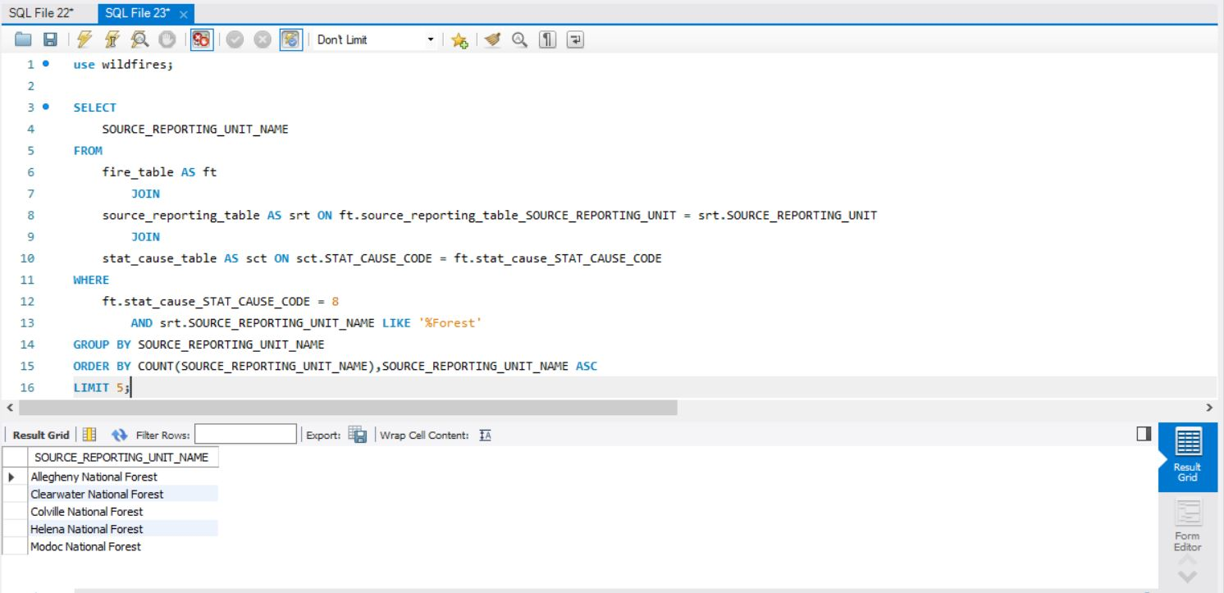

## Query 3

### Question

One advocacy group says human actions and nature are equally to blame for most wildfires. Write a query that can help determine the truth of this statement.

### Notes/Comments About SQL Query and Results (Include # of Rows in Result)

The query results show that the count of damages due to natural causes is 282247 and the count of damages due to human actions is 1107167. Thus, the group’s claim that both human and natural causes are equally responsible for wildfires is incorrect.

### Translation

TRANSLATION: select fire_cause, count of the cause from fire_table joined with stat_cause_table on STAT_CAUSE_CODE where stat_cause_code table STAT_CAUSE_DESCR is neither ‘Miscellaneous’ nor ‘Missing/Undefined’ with result stored as ‘fire_type’, and if STAT_CAUSE_DESCR equals ‘Lightning’, then it is assigned ‘Nature’ otherwise it is assigned ‘Human’ and the result is stored in the column fire_cause.

CLEANUP: SELECT fire_cause, COUNT (*) AS count FROM

(SELECT

IF (STAT_CAUSE_DESCR= ‘Lightning’, ’Nature’, ‘Human’) AS fire_cause FROM

fire_table AS ft JOIN stat_cause_table AS sct ON

ft.stat_cause_table_STAT_CAUSE_CODE = sct. STAT_CAUSE_CODE

WHERE sct.STAT_CAUSE_DESCR NOT IN (‘Miscellaneous’, ’Missing/Undefined’)) AS fire_type

GROUP BY fire_cause;

### Screen Shot of SQL Query and Results

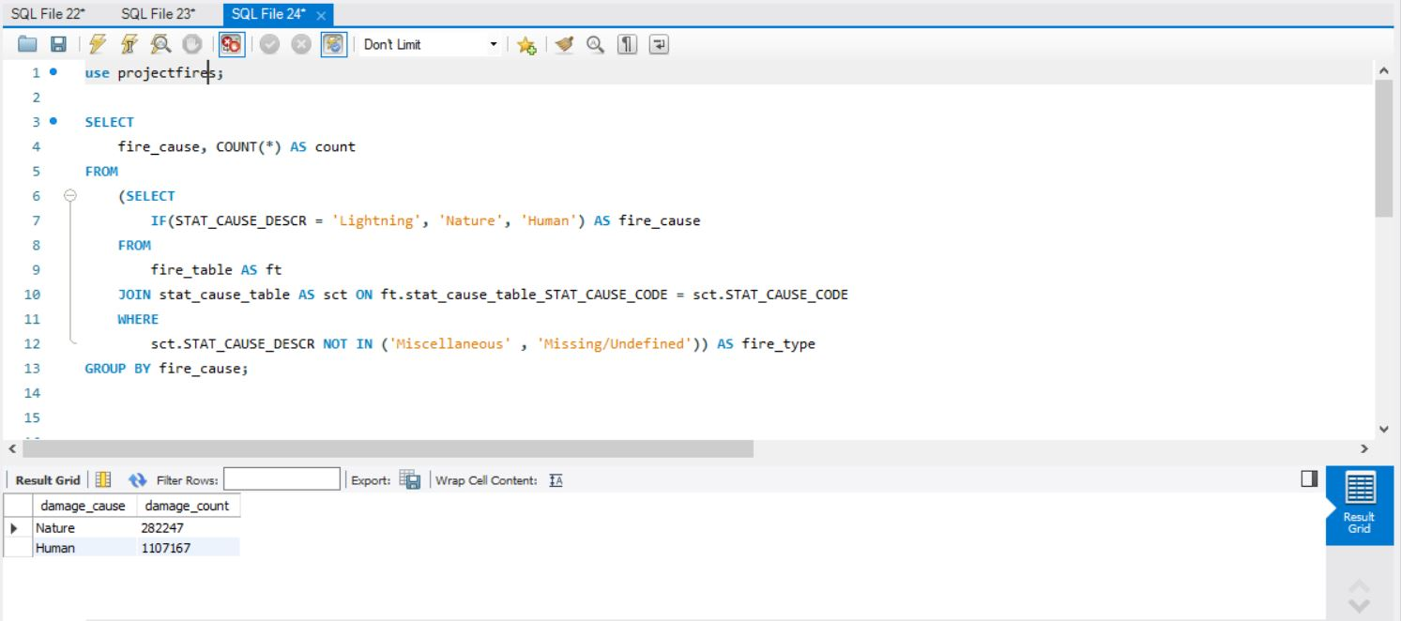

## Query 4

### Question

How many wildfires were reported by at least two units/agencies?

### Notes/Comments About SQL Query and Results (Include # of Rows in Result)

The query returns 76634 wildfires.

### Translation

TRANSLATION: select total count as fire_count from select fire_table FIRE_NAME, COUNT(SOURCE_REPORTING_UNIT) AS reported_units FROM fire_table joined with source_reporting_table on SOURCE_REPORTING_UNIT group by FIRE_NAME havingreported_units greater than or equal to 2

CLEANUP: SELECT COUNT(*) AS fire_count

FROM

(SELECT ft.FIRE_NAME, COUNT(SOURCE_REPORTING_UNIT) AS reported_units

FROM fire_table AS ft

JOIN source_reporting_table AS srt ON ft.source_reporting_table_ SOURCE_REPORTING_UNIT=

srt. SOURCE_REPORTING_UNIT

GROUP BY ft.FIRE_NAME

HAVING reported_units>=2) as fires;

### Screen Shot of SQL Query and Results

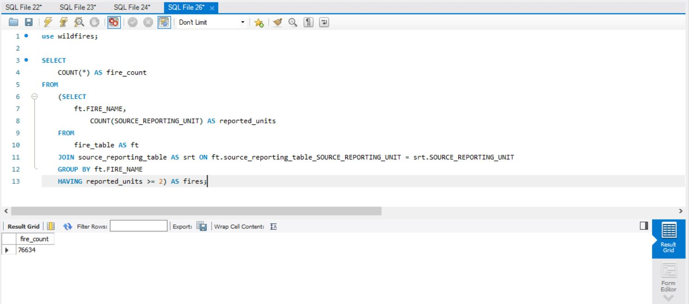

## Query 5

### Question

What were the forests that had only one fire that lasted more than two days?

### Notes/Comments About SQL Query and Results (Include # of Rows in Result)

# of rows in the result: 9

### Translation

TRANSLATION: select SOURCE_REPORTING_UNIT_NAME from fire_table joined with source_reporting_table on SOURCE_REPORTING_UNIT where the difference between fire_table CONT_DATE and fire_table DISCOVERY_DATE is greater than 2 and SOURCE_REPORTING_UNIT_NAME contains ‘Forest’, group the result by SOURCE_REPORTING_UNIT_NAME having count of SOURCE_REPORTING_UNIT_NAME equal to 1

CLEAN-UP: SELECT SOURCE_REPORTING_UNIT_NAME from fire_table ft JOIN source_reporting_table srt ON ft.SOURCE_REPORTING_UNIT=srt. ft.SOURCE_REPORTING_UNIT

WHERE (ft.CONT_DATE- ft.DISCOVERY_DATE) >2 AND

SOURCE_REPORTING_UNIT_NAME LIKE ‘%Forest%’,

GROUP BY SOURCE_REPORTING_UNIT_NAME

HAVING COUNT(SOURCE_REPORTING_UNIT_NAME)= 1;

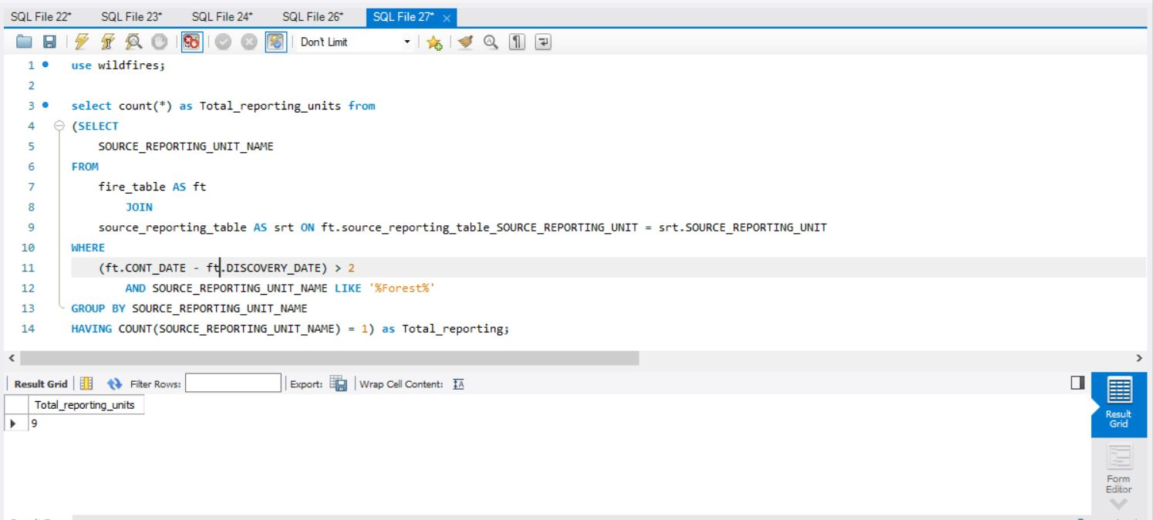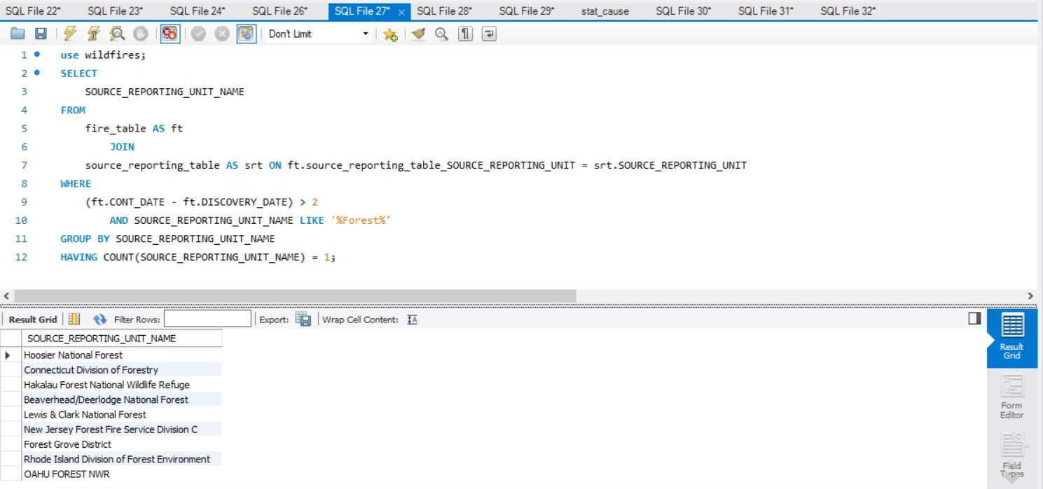

### Screen Shot of SQL Query and Results

## Query 6

### Question

Which state had fires only in the second half of the calendar years?

### Notes/Comments About SQL Query and Results (Include # of Rows in Result)

There is no state where fires occurred only in the second half of the calendar years. So, no row is returned.

### Translation

TRANSLATION: select STATE from fire_table joined with fire_location_table on fire_table location_LATITUDE equals fire_location_table LATITUDE and fire_table location_LONGITUDE equals fire_location_table LONGITUDE where DISCOVERY_DOY is greater than 182 and fire_location_table STATE is not in select STATE from fire_table joined with fire_location_table fire_table location_LATITUDE equals fire_location_table LATITUDE and fire_table location_LONGITUDE equals fire_location_table LONGITUDE where DISCOVERY_DOY is less than 182

CLEAN-UP: select STATE FROM fire_table AS ft JOIN fire_location_table AS flt

ON ft.location_LATITUDE=flt.LATITUDE AND ft.location_LONGITUDE=flt.LONGITUDE

WHERE DISCOVERY_DOY>182

AND flt.STATE NOT IN

(SELECT STATE FROM

fire_table AS ft JOIN fire_location_table AS flt

ON ft.location_LATITUDE=flt.LATITUDE AND ft.location_LONGITUDE=flt.LONGITUDE

WHERE DISCOVERY_DOY<182);

### Screen Shot of SQL Query and Results

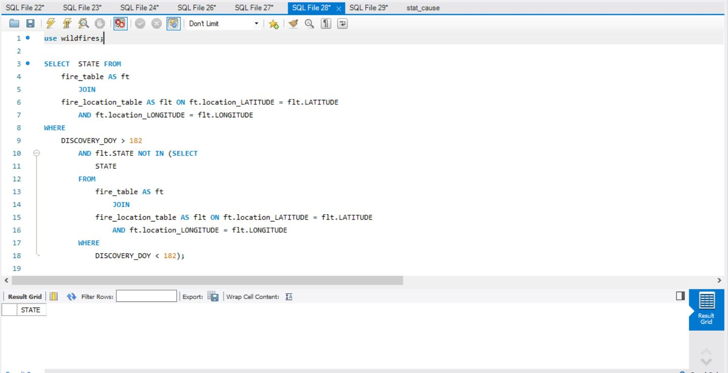

# Data Review for MongoDB

## Assumptions/Notes About Data Collections, Attributes and Relationships between Collections

* The given data has been loaded into MongoDB in two collections: *fires* and *nwcg.*
* These collections in turn consist of documents that contain attributes in *field: value* pairs or embedded documents.
* The ‘_id’ field is the primary key in each document.
* Both *fires* and *nwcg* collections have a common field: ‘unitID’.
* The following fields contain ‘integer’ data type:

1. FOD_ID
2. FIRE_YEAR
3. DISCOVERY_DOY
4. STAT_CAUSE_CODE
5. OWNER_CODE

* The following fields contain ‘float’ data type:

1. CONT_DOY
2. FIRE_SIZE
3. LATITUDE
4. LONGITUDE
5. FIPS_CODE

* ‘CONT_DATE and ‘DISCOVERY_DATE’ contain data in ‘date’ format.

# Physical Mongo Database

## Assumptions/Notes About Data Set

* A new document STAT_PROP_CAUSE has been created that contains the embedded documents STAT_CAUSE_DESCR (data type: String) and STAT_CAUSE_CODE (data type:Integer).
* Missing values and duplicate data have been removed.

## Screen shot of Physical Database objects (Database, Collections and Attributes)

## Data in the Database

|  |  |  |
| --- | --- | --- |
| **Collection Name** | **Relationshps With Other Collections (if any)** | **# of Documents in Collection** |
| fires |  | 1880465 |
| nwcg |  | 5867 |

# MongoDB Queries/Code

## Query 1

### Question

A leading beverage company has announced a billion-dollar fund for removing debris from forests, rivers and mountains in the US. All states are interested. Which 2 states have the least chance to win a share of the fund?

### Notes/Comments About MongoDB Query/Code and Results (Include # of Documents in Result)

The least chance to win a share can be interpreted in two ways:

1. Those states that didn’t suffer a forest fire due to debris will have no/least chance to win a share of the fund.
   1. As per Query1 – Part 1 results, every state suffered forest fire due to debris
2. Those states that suffered minimum in-terms of FIRE_SIZE will have least chance to win a share of the fund.

Results:

States – DC , RI

Count - 2

### Translation

Filter (MATCH) all the forest fires due to debris burning

Then GROUP by STATE and compute the SUM of FIRE_SIZE as TOTAL_FIRE_SIZE

Then SORT the results in ascending order based on SUM of FIRE_SIZE (TOTAL_FIRE_SIZE)

PROJECT the STATE

And LIMIT the result set to top 2 states

### Screen Shot of MongoDB Query/Code and Results

Part 1

## Query 2

### Question

One of the reporting agencies has suggested that children be banned from its forests unless there is one adult for every 4 children in a group visiting a forest. Name top 5 forests where this would be the least appropriate

### Notes/Comments About MongoDB Query/Code and Results (Include # of Documents in Result)

For all those forests which had least no of forest fires due to Children, the reporting agencies suggestion would be least appropriate

As per data set, fire due to Children is given a code value 8. The query uses STAT_CAUSE_CODE 8 to identify fires due to Children

Result:

"Allegheny National Forest"

"Clearwater National Forest"

"Colville National Forest"

"Custer Gallatin National Forest"

"Custer National Forest"

**Count**: 5

### Translation

Filter (MATCH) all the source reporting units which are Forest(s) and all the forest fires due to Children (STAT_CAUSE_CODE - 8)

Then GROUP by SOURCE_REPORTING_UNIT_NAME and compute the COUNT of fires as count

Then SORT the results in ascending order based on the count

PROJECT the SOURCE_REPORTING_UNIT_NAME

And LIMIT the result set to top 5 Forests

### Screen Shot of MongoDB Query/Code and Results

## Query 3

### Question

One advocacy group says human actions and nature are equally to blame for most wildfires. Write a query that can help determine the truth of this statement.

### Notes/Comments About MongoDB Query/Code and Results (Include # of Documents in Result)

All the forest fires occurred due to “Lightening” are considered as caused by Nature, all the others [such as 'Debris Burning', 'Campfire', 'Equipment Use', 'Arson', 'Children', 'Railroad', 'Smoking', 'Powerline', 'Structure', 'Fireworks'] except Miscellaneous OR Missing/Undefined are categorized into human actions.

Result:

"Nature", "count" : 278468

"Human", "count" : 1111469

"Miscellaneous/Unknown", "count" : 490528

### Translation

Summarize all the forest fires due to “Lightening” as “Nature”, all the forest fires due to “Miscellaneous” OR “Missing/Undefined” as "Miscellaneous/Unknown" and all the others as “Human”

GROUP by Summary (Nature [OR] Human [OR] Miscellaneous/Unknown) and COUNT the values in each group

### Screen Shot of MongoDB Query/Code and Results

## Query 4

### Question

How many wildfires were reported by at least two units/agencies?

### Notes/Comments About MongoDB Query/Code and Results (Include # of Documents in Result)

Each fire identified by FIRE_NAME reported by two or more SOURCE_REPORTING_UNIT(s) must be retrieved

**RESULT**

Count: 50954

### Translation

PROJECT FIRE_NAME and SOURCE_REPORTING_UNIT

Then GROUP by FIRE_NAME and COUNT the no of different SOURCE_REPORTING_UNITs into unitsReported

Then MATCH all the fires which have unitsReported greater than or equal to two

### Screen Shot of MongoDB Query/Code and Results

## Query 5

### Question

What were the forests that had only one fire that lasted more than two days?

### Notes/Comments About MongoDB Query/Code and Results (Include # of Documents in Result)

The duration between DISCOVERY_DATE and CONT_DATE tells us the no od days the fire lasted. All those forests which had a forest fire for 2 days or more are retrieved

**RESULT**

{ "_id" : { "SOURCE_REPORTING_UNIT_NAME" : "Rhode Island Division of Forest Environment" }, "count" : 1 }

{ "_id" : { "SOURCE_REPORTING_UNIT_NAME" : "Hakalau Forest National Wildlife Refuge" }, "count" : 1 }

{ "_id" : { "SOURCE_REPORTING_UNIT_NAME" : "Connecticut Division of Forestry" }, "count" : 1 }

{ "_id" : { "SOURCE_REPORTING_UNIT_NAME" : "Pike and San Isabel National Forest" }, "count" : 1 }

{ "_id" : { "SOURCE_REPORTING_UNIT_NAME" : "Ozark-St. Francis Nat Forests" }, "count" : 1 }

{ "_id" : { "SOURCE_REPORTING_UNIT_NAME" : "Division of Forestry and Wildlife" }, "count" : 1 }

{ "_id" : { "SOURCE_REPORTING_UNIT_NAME" : "Ozark & St. Francis National Forests" }, "count" : 1 }

{ "_id" : { "SOURCE_REPORTING_UNIT_NAME" : "New Jersey Forest Fire Service Division C" }, "count" : 1 }

{ "_id" : { "SOURCE_REPORTING_UNIT_NAME" : "Forest Grove District" }, "count" : 1 }

{ "_id" : { "SOURCE_REPORTING_UNIT_NAME" : "Hoosier National Forest" }, "count" : 1 }

Count: 10

### Translation

Compute difference between DISCOVERY_DATE and CONT_DATE in terms of days into a new field “duration”

Then MATCH those fires if the “duration” is greater than 2 days

Then Match those fires if SOURCE_REPORTING_UNIT_NAME contains “Forest”

Then GROUP by SOURCE_REPORTING_UNIT_NAME

Then MATCH those fires which had a total one fire for a SOURCE_REPORTING_UNIT_NAME

Then PROJECT SOURCE_REPORTING_UNIT_NAME and count

### Screen Shot of MongoDB Query/Code and Results

### A screen shot of a computer Description automatically generatedQuery 6

### Question

Which state had fires only in the second half of the calendar years?

### Notes/Comments About MongoDB Query/Code and Results (Include # of Documents in Result)

Identify all the states which had fires in the second half of the calendar years i.e., DISCOVERY_DOY greater than 182 days

**RESULT:**

NONE

Count: 0

### Translation

### Compute whether the fire occurred in second half by comparing if DISCOVERY_DOY is greater than 182 and add a new field secondHalf

### GROUP by STATE and unique values for secondHalf for each state

### Then MATCH all the fires with only secondHalf with value [true]

### Screen Shot of MongoDB Query/Code and Results

